**PRESS RELEASE**

**FOR IMMEDIATE RELEASE**

**Japan to Invest Rp743 Billion in ACPHEED**

**Jakarta, Kominfo Newsroom** – Japan has committed to investing US$50 million or around Rp743.73 billion for the development of the ASEAN Centre for Public Health Emergencies and Emerging Diseases (ACPHEED).

In a special interview with ANTAR last week, the Ambassador of Japan to the Association of Southeast Asian Nations (ASEAN), Kiya Masahiko, stated that public health is one of the focus areas for Japan in enhancing cooperation with ASEAN.

“The focus of this collaboration is to address various potential issues that may arise in all sectors, including public health. Although we are now out of the COVID-19 pandemic, it could happen again and we must be prepared to face it,” said Masahiko.

This year marks the 50th anniversary of friendship and cooperation between Japan and ASEAN. The commemorative 50th ASEAN-Japan partnership summit will be held in Tokyo in December.

One of the focuses of cooperation for the 50th anniversary of the partnership is to promote universal health coverage, particularly for emerging diseases.

“Therefore, Japan is committed to investing US$50 million in the ASEAN Centre for Public Health Emergencies and Emerging Diseases,” he said.

The establishment of the ASEAN Centre for Public Health Emergencies and Emerging Diseases (ACPHEED) was agreed upon at the 15th ASEAN Health Ministers Meeting in Nusa Dua, Bali, in May 2022. It is expected to strengthen the defense of ASEAN countries in facing potential pandemics in the future.

“One of the agreements we made was to establish the ASEAN Centre for Public Health Emergencies and Emerging Diseases. This will be the center for ASEAN cooperation to face potential outbreaks or pandemics in the future,” said the Health Minister of Indonesia, Budi Gunadi, on 14 May 2022.

The three pillars of the health emergency center are prevention, detection, and response.

Meanwhile, Indonesia is the ASEAN Chair this year with the theme of “ASEAN Matters: Epicentrum of Growth”.

Under the Epicentrum of Growth pillar, Indonesia aims to emphasize important elements that consist of health architecture, energy resilience, food security, and financial stability.

The 42nd ASEAN Summit will be held on 9 – 11 May in Labuan Bajo, East Nusa Tenggara. (Shofi/Elvira/TR)

***

For more information, please contact:

**Director General of Public Information and Communications of the Ministry of Communications and Informatics – Usman Kansong (0816785320).**

Get other information at <https://infopublik.id>

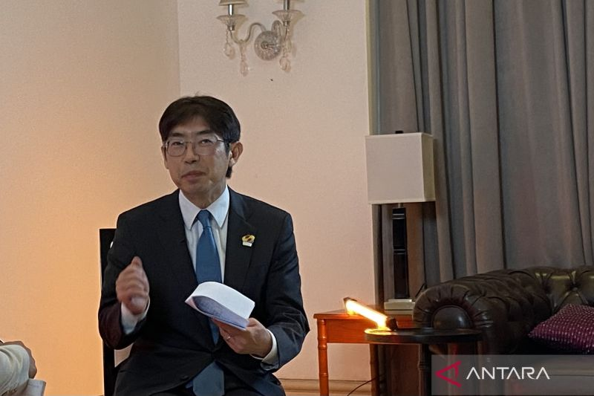

The Ambassador of Japan to the Association of Southeast Asian Nations (ASEAN), Kiya Masahiko, in a special interview with ANTARA in Jakarta on Friday (14 April 2023). (ANTARA/Shofi Ayudiana)